# CI/CD

CI and CD are acronyms to represent modern development practices.

CI stands for continuous integration, which is a practice that focuses on developers integrating code regularly into a shared repository. Check-ins are verified by automated builds and testing to ensure bugs are caught often and early.

CD, on the other hand, can either mean continuous delivery or continuous deployment. Both are very similar but have a distinct difference. Continuous delivery is automating the release process by deploying changes on a schedule or at the click of a button. Continuous deployment on the other hand, deploys changes automatically after passing all stages of a production pipeline.

Continuous deployment and continuous delivery are very similar in practice and both are an extension of continuous integration in an automated DevOps environment.

## Some tools for CI:

**Jenkins:**Jenkins is an open-source CI tool written in Java. Some of its main features are:

* Compatible with most OS and versions of Linux, Mac OS and Windows.
* Easy installation
* Easily set up and configured with its web interface
* Plugins – there are over 1500 plugins to

**TeamCity:**TeamCity, also written in Java, main features include:

* Configure builds in DSL
* Project level cloud profiles
* Remote run and pre-tested commit

**Travis CI:**TravisCI is free for open source projects. Its main features include:

* Hosted – not dependant on any platform
* Parallel testing
* Easy setup, no installation

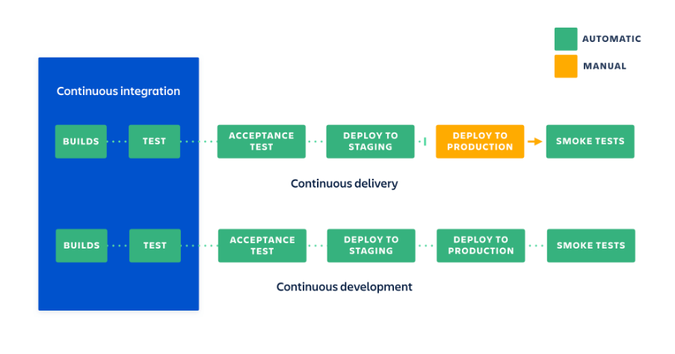

## Recommendation:

Due to its flexibility, compatibility, ease of use and as an open-source tool, I recommend we use Jenkins as our continuous integration server.